**Experiment No. – 1.1**

**Student Name: Milan Sharma UID: 23MAI10003**

**Branch: ME – CSE - AIML Section/Group: 23MAI – 1 (A)**

**Semester: 2nd Date of Performance: 17Jan2023**

**Subject Name: Machine Learning Lab Subject Code: 23 CSH 651**

Aim of the Experiment:

Write a program in Python to implement Linear Regression Algorithm.

**Theory:**

Linear regression is a type of supervised machine learning algorithm that computes the linear relationship between a dependent variable and one or more independent features. When the number of the independent feature, is 1 then it is known as Univariate Linear regression.

This is the simplest form of linear regression, and it involves only one independent variable and one dependent variable.

The equation for simple linear regression is:

Y= mX + b

where:

* Y is the dependent variable
* X is the independent variable
* m is the slope
* b is constant

**Code:**

import numpy as np

import matplotlib.pyplot as plt

# A basic implementation of linear regression with one variable

# Part of Cosmos by OpenGenus Foundation

def estimate_coef(x, y):

# number of observations/points

n = np.size(x)

# mean of x and y vector

m_x, m_y = np.mean(x), np.mean(y)

# calculating cross-deviation and deviation about x

SS_xy = np.sum(y * x - n * m_y * m_x)

SS_xx = np.sum(x * x - n * m_x * m_x)

# calculating regression coefficients

b_1 = SS_xy / SS_xx

b_0 = m_y - b_1 * m_x

return (b_0, b_1)

def plot_regression_line(x, y, b):

# plotting the actual points as scatter plot

plt.scatter(x, y, color="m", marker="o", s=30)

# predicted response vector

y_pred = b[0] + b[1] * x

# plotting the regression line

plt.plot(x, y_pred, color="r")

# putting labels

plt.xlabel('x')

plt.ylabel('y')

# function to show plot

plt.show()

print("\t\t\tMilan Sharma 23MAI10003")

def main():

# observations

x = np.array([0, 1, 2, 3, 4, 5, 6, 7, 8, 9])

y = np.array([1, 3, 2, 5, 7, 8, 8, 9, 10, 12])

print("x = ([0, 1, 2, 3, 4, 5, 6, 7, 8, 9])")

print("y = ([1, 3, 2, 5, 7, 8, 8, 9, 10, 12])\n")

# estimating coefficients

b = estimate_coef(x, y)

print("Estimated coefficients are:\nb_0 = {} \

\nb_1 = {}".format(b[0], b[1]))

# plotting regression line

plot_regression_line(x, y, b)

if __name__ == "__main__":

main()

Output:

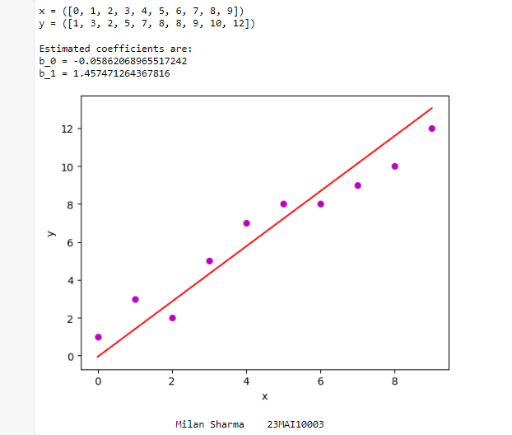

**Learning Outcomes:**

* Learned to implement Linear Regression Algorithmusing python.
* Learned to plot regression line using matplot lib.